================================================================================
SECTION 1: ENVIRONMENT SETUP AND IMPORTS
================================================================================
✓ gdown already installed
✓ shap already installed
Installing scikit-learn...
✓ scikit-learn installed successfully
✓ tensorflow already installed
✓ seaborn already installed
✓ pandas already installed

✓ All imports successful!

================================================================================
SECTION 2: GPU CONFIGURATION AND SYSTEM CHECK
================================================================================

--- GPU Status ---
TensorFlow Version: 2.19.0
✓ GPU Available: 1 GPU(s) detected
GPU 0: /physical_device:GPU:0
✓ GPU memory growth enabled

--- System Resources ---
Total RAM: 12.67 GB
Available RAM: 8.82 GB
Free Disk Space: 73.69 GB

✓ Random seed set to 42 for reproducibility

================================================================================
SECTION 3: CONFIGURATION AND HYPERPARAMETERS
================================================================================

--- Configuration Summary ---
Training samples: 500,000 (per class: 250,000)
Test samples: 100,000
Max URL length: 200
Embedding dimension: 64
Batch size: 256
Max epochs: 20
Learning rate: 0.001

✓ Configuration loaded successfully!

================================================================================
SECTION 4: DATA DOWNLOAD AND EXTRACTION
================================================================================

Step 1: Mounting Google Drive...
Drive already mounted at /content/drive; to attempt to forcibly remount, call drive.mount("/content/drive", force_remount=True).
✓ Google Drive mounted successfully!

Step 2: Downloading dataset...

--- Downloading Dataset ---
File ID: 16iWDam4flWoyrga-42VlNogohx6nPXYm
✓ Dataset already downloaded: /content/dataset.zip (136.62 MB)

Step 3: Extracting dataset...

--- Extracting Dataset ---
✓ Dataset already extracted to: /content/dataset

Step 4: Verifying dataset files...

--- Verifying Dataset Files ---
✓ benign_Train.txt: 123.46 MB, 2,000,000 URLs
✓ malign_Train.txt: 52.53 MB, 2,000,000 URLs
✓ benign_Test.txt: 67.19 MB, 1,087,717 URLs
✓ malign_Test.txt: 38.86 MB, 1,480,467 URLs

================================================================================
SECTION 5: DATA LOADING AND PREPROCESSING
================================================================================

⏳ Loading and preprocessing data (this may take a few minutes)...

--- Loading Training Data ---
Loading: benign_Train.txt...
Total URLs in file: 2,000,000
Sampled: 250,000 URLs
Loading: malign_Train.txt...
Total URLs in file: 2,000,000
Sampled: 250,000 URLs

Total training URLs: 500,000
Benign: 250,000
Malign: 250,000

--- Loading Test Data ---
Loading: benign_Test.txt...
Total URLs in file: 1,087,717
Sampled: 50,000 URLs
Loading: malign_Test.txt...
Total URLs in file: 1,480,467
Sampled: 50,000 URLs

Total test URLs: 100,000
Benign: 50,000
Malign: 50,000

--- Preprocessing URLs ---
Converting 500,000 URLs to sequences...
Processed 100,000/500,000 URLs...
Processed 200,000/500,000 URLs...
Processed 300,000/500,000 URLs...
Processed 400,000/500,000 URLs...
Processed 500,000/500,000 URLs...
Sequence shape: (500000, 200)
Converting 100,000 URLs to sequences...
Processed 100,000/100,000 URLs...
Sequence shape: (100000, 200)

--- Creating Validation Split ---
Shuffling training data...
Training set: 450,000 samples
Validation set: 50,000 samples
Test set: 100,000 samples

--- Data Summary ---
X_train shape: (450000, 200)
X_val shape: (50000, 200)
X_test shape: (100000, 200)
y_train distribution: [225000 225000]
y_val distribution: [25000 25000]
y_test distribution: [50000 50000]

✓ Data loading and preprocessing complete!

================================================================================
SECTION 6: DATA VISUALIZATION
================================================================================
Results will be saved to: /content/results

--- Generating Data Visualizations ---
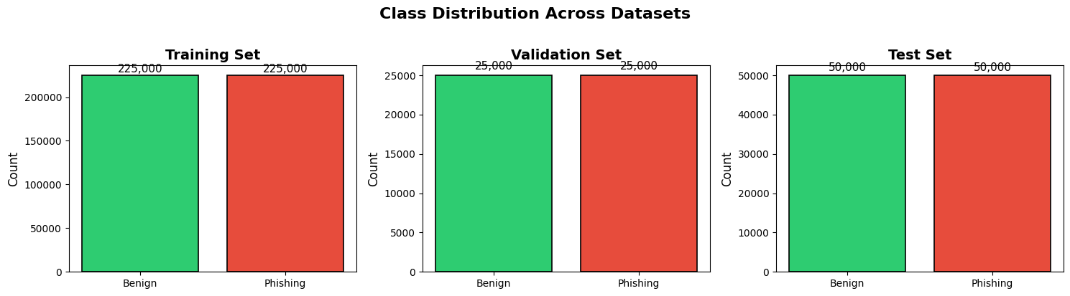
✓ Class distribution plot saved!
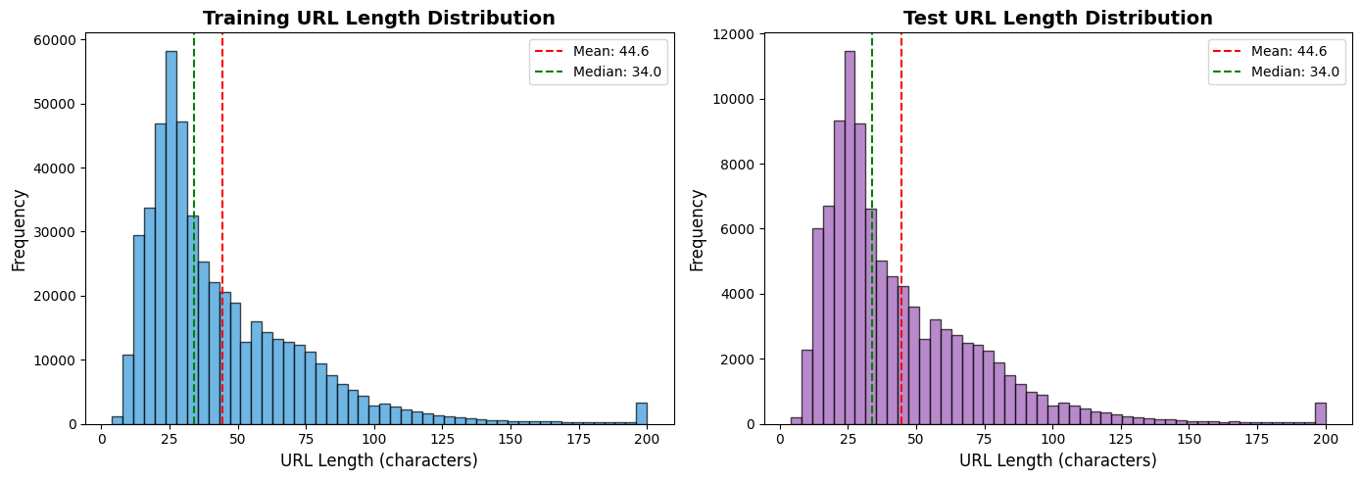
✓ URL length distribution plot saved!

================================================================================
SECTION 7: MODEL ARCHITECTURE
================================================================================

--- Building 1D-CNN Model ---

--- Compiling Model ---
✓ Model compiled successfully!
Optimizer: Adam (lr=0.001)
Loss: Binary Crossentropy
Metrics: Accuracy, Precision, Recall, AUC

--- Model Summary ---
Model: "PhishingDetector_1DCNN"
┏━━━━━━━━━━━━━━━━━━━━━┳━━━━━━━━━━━━━━━━━━━┳━━━━━━━━━━━━┳━━━━━━━━━━━━━━━━━━━┓
┃ Layer (type) ┃ Output Shape ┃ Param # ┃ Connected to ┃
┡━━━━━━━━━━━━━━━━━━━━━╇━━━━━━━━━━━━━━━━━━━╇━━━━━━━━━━━━╇━━━━━━━━━━━━━━━━━━━┩
│ url_input │ (None, 200) │ 0 │ - │
│ (InputLayer) │ │ │ │
├─────────────────────┼───────────────────┼────────────┼───────────────────┤
│ char_embedding │ (None, 200, 64) │ 8,192 │ url_input[0][0] │
│ (Embedding) │ │ │ │
├─────────────────────┼───────────────────┼────────────┼───────────────────┤
│ conv1d_k3 (Conv1D) │ (None, 200, 128) │ 24,704 │ char_embedding[0… │
├─────────────────────┼───────────────────┼────────────┼───────────────────┤
│ conv1d_k5 (Conv1D) │ (None, 200, 128) │ 41,088 │ char_embedding[0… │
├─────────────────────┼───────────────────┼────────────┼───────────────────┤
│ conv1d_k7 (Conv1D) │ (None, 200, 64) │ 28,736 │ char_embedding[0… │
├─────────────────────┼───────────────────┼────────────┼───────────────────┤
│ bn_k3 │ (None, 200, 128) │ 512 │ conv1d_k3[0][0] │
│ (BatchNormalizatio… │ │ │ │
├─────────────────────┼───────────────────┼────────────┼───────────────────┤
│ bn_k5 │ (None, 200, 128) │ 512 │ conv1d_k5[0][0] │
│ (BatchNormalizatio… │ │ │ │
├─────────────────────┼───────────────────┼────────────┼───────────────────┤
│ bn_k7 │ (None, 200, 64) │ 256 │ conv1d_k7[0][0] │
│ (BatchNormalizatio… │ │ │ │
├─────────────────────┼───────────────────┼────────────┼───────────────────┤
│ maxpool_k3 │ (None, 128) │ 0 │ bn_k3[0][0] │
│ (GlobalMaxPooling1… │ │ │ │
├─────────────────────┼───────────────────┼────────────┼───────────────────┤
│ maxpool_k5 │ (None, 128) │ 0 │ bn_k5[0][0] │
│ (GlobalMaxPooling1… │ │ │ │
├─────────────────────┼───────────────────┼────────────┼───────────────────┤
│ maxpool_k7 │ (None, 64) │ 0 │ bn_k7[0][0] │
│ (GlobalMaxPooling1… │ │ │ │
├─────────────────────┼───────────────────┼────────────┼───────────────────┤
│ concat │ (None, 320) │ 0 │ maxpool_k3[0][0], │
│ (Concatenate) │ │ │ maxpool_k5[0][0], │
│ │ │ │ maxpool_k7[0][0] │
├─────────────────────┼───────────────────┼────────────┼───────────────────┤
│ dense_1 (Dense) │ (None, 128) │ 41,088 │ concat[0][0] │
├─────────────────────┼───────────────────┼────────────┼───────────────────┤
│ bn_dense_1 │ (None, 128) │ 512 │ dense_1[0][0] │
│ (BatchNormalizatio… │ │ │ │
├─────────────────────┼───────────────────┼────────────┼───────────────────┤
│ dropout_1 (Dropout) │ (None, 128) │ 0 │ bn_dense_1[0][0] │
├─────────────────────┼───────────────────┼────────────┼───────────────────┤
│ dense_2 (Dense) │ (None, 64) │ 8,256 │ dropout_1[0][0] │
├─────────────────────┼───────────────────┼────────────┼───────────────────┤
│ bn_dense_2 │ (None, 64) │ 256 │ dense_2[0][0] │
│ (BatchNormalizatio… │ │ │ │
├─────────────────────┼───────────────────┼────────────┼───────────────────┤
│ dropout_2 (Dropout) │ (None, 64) │ 0 │ bn_dense_2[0][0] │
├─────────────────────┼───────────────────┼────────────┼───────────────────┤
│ output (Dense) │ (None, 1) │ 65 │ dropout_2[0][0] │
└─────────────────────┴───────────────────┴────────────┴───────────────────┘
Total params: 154,177 (602.25 KB)
Trainable params: 153,153 (598.25 KB)
Non-trainable params: 1,024 (4.00 KB)

Total parameters: 154,177
Estimated model size: 0.59 MB (float32)

✓ Model architecture diagram saved!

================================================================================
SECTION 8: TRAINING CALLBACKS
================================================================================

--- Setting Up Training Callbacks ---
✓ Early Stopping: patience=5
✓ LR Reducer: factor=0.5, patience=3
✓ Model Checkpoint: monitoring val_auc
✓ TensorBoard: logs at /content/results/tensorboard_logs
✓ Custom Training Logger

================================================================================
SECTION 9: MODEL TRAINING
================================================================================

⏳ Starting training (this will take 15-30 minutes on GPU)...

--- Starting Model Training ---
Training samples: 450,000
Validation samples: 50,000
Batch size: 256
Max epochs: 20
Device: /GPU:0
Steps per epoch: 1757
Validation steps: 195

--------------------------------------------------
Training started at: 2026-01-11 17:29:07
--------------------------------------------------
Epoch 1/20
1758/1758 ━━━━━━━━━━━━━━━━━━━━ 0s 22ms/step - accuracy: 0.9371 - auc: 0.9803 - loss: 0.1574 - precision: 0.9559 - recall: 0.9164
Epoch 1: val_auc improved from -inf to 0.99441, saving model to /content/phishing_detector_model.keras

📊 Epoch 1 Summary:
Train - Loss: 0.1203, Acc: 0.9517, AUC: 0.9894
Val - Loss: 0.0968, Acc: 0.9588, AUC: 0.9944
1758/1758 ━━━━━━━━━━━━━━━━━━━━ 50s 24ms/step - accuracy: 0.9371 - auc: 0.9803 - loss: 0.1573 - precision: 0.9559 - recall: 0.9164 - val_accuracy: 0.9588 - val_auc: 0.9944 - val_loss: 0.0968 - val_precision: 0.9465 - val_recall: 0.9726 - learning_rate: 0.0010
Epoch 2/20
1756/1758 ━━━━━━━━━━━━━━━━━━━━ 0s 16ms/step - accuracy: 0.9625 - auc: 0.9935 - loss: 0.0941 - precision: 0.9722 - recall: 0.9521
Epoch 2: val_auc improved from 0.99441 to 0.99526, saving model to /content/phishing_detector_model.keras

📊 Epoch 2 Summary:
Train - Loss: 0.0910, Acc: 0.9641, AUC: 0.9939
Val - Loss: 0.0921, Acc: 0.9608, AUC: 0.9953
1758/1758 ━━━━━━━━━━━━━━━━━━━━ 66s 17ms/step - accuracy: 0.9625 - auc: 0.9935 - loss: 0.0941 - precision: 0.9722 - recall: 0.9521 - val_accuracy: 0.9608 - val_auc: 0.9953 - val_loss: 0.0921 - val_precision: 0.9474 - val_recall: 0.9758 - learning_rate: 0.0010
Epoch 3/20
1757/1758 ━━━━━━━━━━━━━━━━━━━━ 0s 16ms/step - accuracy: 0.9673 - auc: 0.9948 - loss: 0.0838 - precision: 0.9754 - recall: 0.9588
Epoch 3: val_auc improved from 0.99526 to 0.99564, saving model to /content/phishing_detector_model.keras

📊 Epoch 3 Summary:
Train - Loss: 0.0817, Acc: 0.9681, AUC: 0.9950
Val - Loss: 0.0920, Acc: 0.9616, AUC: 0.9956
1758/1758 ━━━━━━━━━━━━━━━━━━━━ 30s 17ms/step - accuracy: 0.9673 - auc: 0.9948 - loss: 0.0838 - precision: 0.9754 - recall: 0.9588 - val_accuracy: 0.9616 - val_auc: 0.9956 - val_loss: 0.0920 - val_precision: 0.9467 - val_recall: 0.9784 - learning_rate: 0.0010
Epoch 4/20
1755/1758 ━━━━━━━━━━━━━━━━━━━━ 0s 16ms/step - accuracy: 0.9706 - auc: 0.9956 - loss: 0.0761 - precision: 0.9779 - recall: 0.9628
Epoch 4: val_auc improved from 0.99564 to 0.99574, saving model to /content/phishing_detector_model.keras

📊 Epoch 4 Summary:
Train - Loss: 0.0745, Acc: 0.9713, AUC: 0.9958
Val - Loss: 0.0958, Acc: 0.9612, AUC: 0.9957
1758/1758 ━━━━━━━━━━━━━━━━━━━━ 30s 17ms/step - accuracy: 0.9706 - auc: 0.9956 - loss: 0.0761 - precision: 0.9779 - recall: 0.9628 - val_accuracy: 0.9612 - val_auc: 0.9957 - val_loss: 0.0958 - val_precision: 0.9433 - val_recall: 0.9814 - learning_rate: 0.0010
Epoch 5/20
1755/1758 ━━━━━━━━━━━━━━━━━━━━ 0s 16ms/step - accuracy: 0.9732 - auc: 0.9963 - loss: 0.0698 - precision: 0.9796 - recall: 0.9665
Epoch 5: val_auc improved from 0.99574 to 0.99600, saving model to /content/phishing_detector_model.keras

📊 Epoch 5 Summary:
Train - Loss: 0.0688, Acc: 0.9736, AUC: 0.9964
Val - Loss: 0.0881, Acc: 0.9643, AUC: 0.9960
1758/1758 ━━━━━━━━━━━━━━━━━━━━ 29s 17ms/step - accuracy: 0.9732 - auc: 0.9963 - loss: 0.0698 - precision: 0.9796 - recall: 0.9665 - val_accuracy: 0.9643 - val_auc: 0.9960 - val_loss: 0.0881 - val_precision: 0.9497 - val_recall: 0.9804 - learning_rate: 0.0010
Epoch 6/20
1758/1758 ━━━━━━━━━━━━━━━━━━━━ 0s 16ms/step - accuracy: 0.9751 - auc: 0.9967 - loss: 0.0649 - precision: 0.9808 - recall: 0.9691
Epoch 6: val_auc did not improve from 0.99600

📊 Epoch 6 Summary:
Train - Loss: 0.0640, Acc: 0.9755, AUC: 0.9968
Val - Loss: 0.0984, Acc: 0.9603, AUC: 0.9958
1758/1758 ━━━━━━━━━━━━━━━━━━━━ 30s 17ms/step - accuracy: 0.9751 - auc: 0.9967 - loss: 0.0649 - precision: 0.9808 - recall: 0.9691 - val_accuracy: 0.9603 - val_auc: 0.9958 - val_loss: 0.0984 - val_precision: 0.9404 - val_recall: 0.9828 - learning_rate: 0.0010
Epoch 7/20
1756/1758 ━━━━━━━━━━━━━━━━━━━━ 0s 16ms/step - accuracy: 0.9772 - auc: 0.9971 - loss: 0.0602 - precision: 0.9825 - recall: 0.9717
Epoch 7: val_auc did not improve from 0.99600

📊 Epoch 7 Summary:
Train - Loss: 0.0593, Acc: 0.9776, AUC: 0.9972
Val - Loss: 0.0750, Acc: 0.9709, AUC: 0.9960
1758/1758 ━━━━━━━━━━━━━━━━━━━━ 29s 17ms/step - accuracy: 0.9772 - auc: 0.9971 - loss: 0.0602 - precision: 0.9825 - recall: 0.9717 - val_accuracy: 0.9709 - val_auc: 0.9960 - val_loss: 0.0750 - val_precision: 0.9704 - val_recall: 0.9715 - learning_rate: 0.0010
Epoch 8/20
1758/1758 ━━━━━━━━━━━━━━━━━━━━ 0s 16ms/step - accuracy: 0.9787 - auc: 0.9975 - loss: 0.0563 - precision: 0.9832 - recall: 0.9740
Epoch 8: val_auc did not improve from 0.99600

📊 Epoch 8 Summary:
Train - Loss: 0.0554, Acc: 0.9790, AUC: 0.9975
Val - Loss: 0.1052, Acc: 0.9599, AUC: 0.9954
1758/1758 ━━━━━━━━━━━━━━━━━━━━ 29s 16ms/step - accuracy: 0.9787 - auc: 0.9975 - loss: 0.0563 - precision: 0.9832 - recall: 0.9740 - val_accuracy: 0.9599 - val_auc: 0.9954 - val_loss: 0.1052 - val_precision: 0.9386 - val_recall: 0.9842 - learning_rate: 0.0010
Epoch 9/20
1755/1758 ━━━━━━━━━━━━━━━━━━━━ 0s 16ms/step - accuracy: 0.9803 - auc: 0.9977 - loss: 0.0525 - precision: 0.9840 - recall: 0.9763
Epoch 9: val_auc did not improve from 0.99600

📊 Epoch 9 Summary:
Train - Loss: 0.0516, Acc: 0.9805, AUC: 0.9978
Val - Loss: 0.0980, Acc: 0.9636, AUC: 0.9950
1758/1758 ━━━━━━━━━━━━━━━━━━━━ 29s 16ms/step - accuracy: 0.9803 - auc: 0.9977 - loss: 0.0525 - precision: 0.9840 - recall: 0.9763 - val_accuracy: 0.9636 - val_auc: 0.9950 - val_loss: 0.0980 - val_precision: 0.9483 - val_recall: 0.9807 - learning_rate: 0.0010
Epoch 10/20
1755/1758 ━━━━━━━━━━━━━━━━━━━━ 0s 16ms/step - accuracy: 0.9813 - auc: 0.9980 - loss: 0.0494 - precision: 0.9847 - recall: 0.9777
Epoch 10: ReduceLROnPlateau reducing learning rate to 0.0005000000237487257.

Epoch 10: val_auc did not improve from 0.99600

📊 Epoch 10 Summary:
Train - Loss: 0.0486, Acc: 0.9818, AUC: 0.9980
Val - Loss: 0.0960, Acc: 0.9647, AUC: 0.9950
1758/1758 ━━━━━━━━━━━━━━━━━━━━ 29s 17ms/step - accuracy: 0.9813 - auc: 0.9980 - loss: 0.0494 - precision: 0.9847 - recall: 0.9777 - val_accuracy: 0.9647 - val_auc: 0.9950 - val_loss: 0.0960 - val_precision: 0.9496 - val_recall: 0.9815 - learning_rate: 0.0010
Epoch 11/20
1756/1758 ━━━━━━━━━━━━━━━━━━━━ 0s 16ms/step - accuracy: 0.9846 - auc: 0.9985 - loss: 0.0418 - precision: 0.9872 - recall: 0.9818
Epoch 11: val_auc did not improve from 0.99600

📊 Epoch 11 Summary:
Train - Loss: 0.0387, Acc: 0.9860, AUC: 0.9986
Val - Loss: 0.1083, Acc: 0.9662, AUC: 0.9930
1758/1758 ━━━━━━━━━━━━━━━━━━━━ 30s 17ms/step - accuracy: 0.9846 - auc: 0.9985 - loss: 0.0418 - precision: 0.9872 - recall: 0.9818 - val_accuracy: 0.9662 - val_auc: 0.9930 - val_loss: 0.1083 - val_precision: 0.9536 - val_recall: 0.9801 - learning_rate: 5.0000e-04
Epoch 12/20
1757/1758 ━━━━━━━━━━━━━━━━━━━━ 0s 16ms/step - accuracy: 0.9868 - auc: 0.9987 - loss: 0.0364 - precision: 0.9890 - recall: 0.9846
Epoch 12: val_auc did not improve from 0.99600

📊 Epoch 12 Summary:
Train - Loss: 0.0342, Acc: 0.9877, AUC: 0.9988
Val - Loss: 0.1086, Acc: 0.9684, AUC: 0.9923
1758/1758 ━━━━━━━━━━━━━━━━━━━━ 29s 17ms/step - accuracy: 0.9868 - auc: 0.9987 - loss: 0.0364 - precision: 0.9890 - recall: 0.9846 - val_accuracy: 0.9684 - val_auc: 0.9923 - val_loss: 0.1086 - val_precision: 0.9601 - val_recall: 0.9774 - learning_rate: 5.0000e-04
Epoch 12: early stopping
Restoring model weights from the end of the best epoch: 7.

--------------------------------------------------
Training completed at: 2026-01-11 17:35:58
Total training time: 6.85 minutes
--------------------------------------------------

✓ Training history saved to: /content/training_history.npy

================================================================================
SECTION 10: TRAINING VISUALIZATION
================================================================================

--- Plotting Training History ---
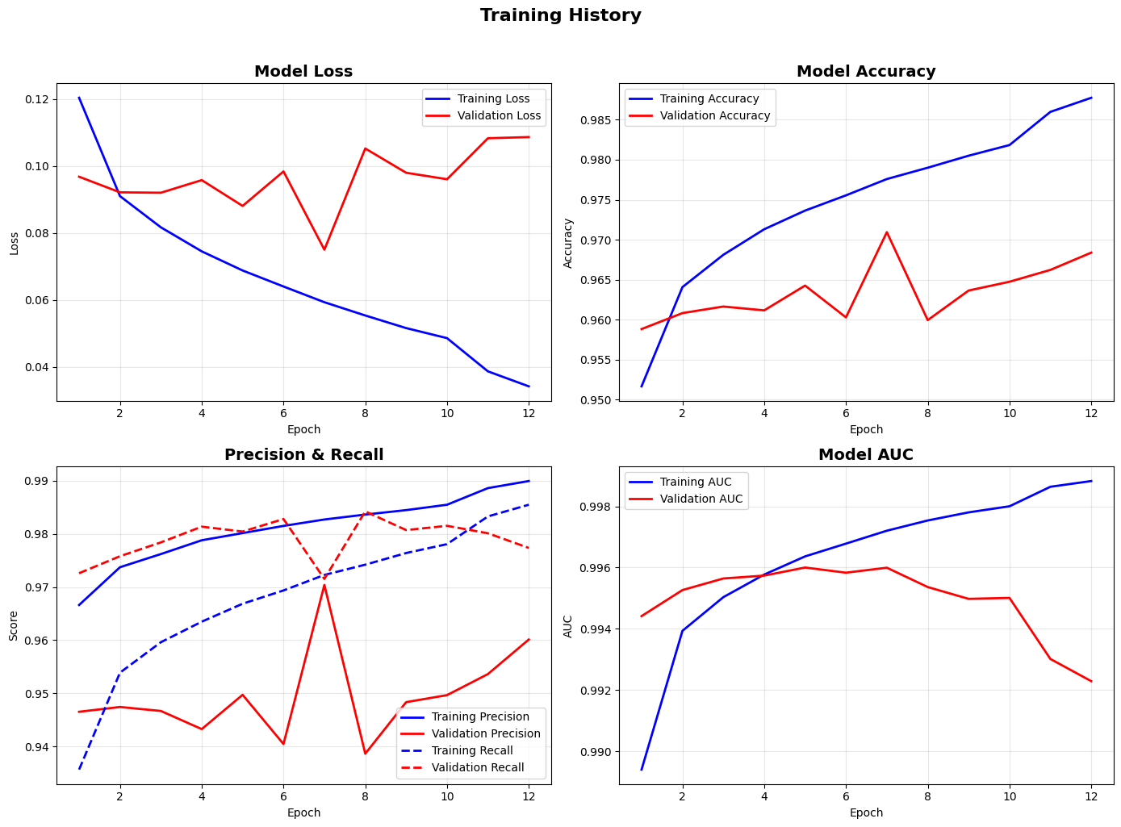
✓ Training history plots saved!

--- Best Metrics Achieved ---
Best Validation Loss: 0.0750 (Epoch 7)
Best Validation Accuracy: 0.9709 (Epoch 7)
Best Validation AUC: 0.9960 (Epoch 5)

================================================================================
SECTION 11: MODEL EVALUATION
================================================================================

--- Evaluating Model on Test Set ---
Test samples: 100,000
Generating predictions...
391/391 ━━━━━━━━━━━━━━━━━━━━ 3s 6ms/step

--- Classification Metrics ---

========================================
METRIC VALUE
========================================
Accuracy 0.9709
Precision 0.9689
Recall 0.9730
F1-Score 0.9709
ROC-AUC 0.9965
========================================

--- Detailed Classification Report ---
precision recall f1-score support

Benign 0.97 0.97 0.97 50000
Phishing 0.97 0.97 0.97 50000

accuracy 0.97 100000
macro avg 0.97 0.97 0.97 100000
weighted avg 0.97 0.97 0.97 100000

--- Plotting Confusion Matrix ---
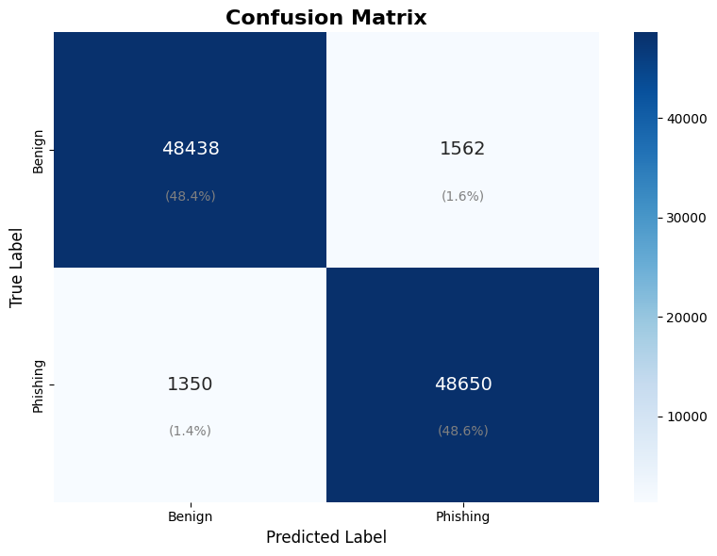

Confusion Matrix Details:
True Negatives (Benign correctly identified): 48,438
False Positives (Benign misclassified as Phishing): 1,562
False Negatives (Phishing misclassified as Benign): 1,350
True Positives (Phishing correctly identified): 48,650

✓ Confusion matrix saved!

--- Plotting ROC Curve ---
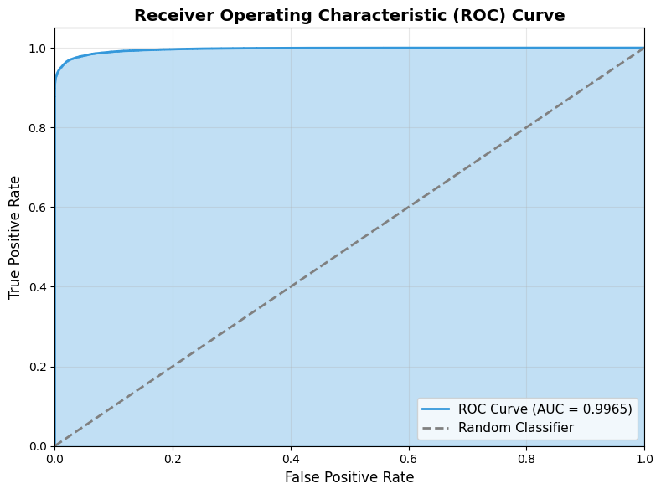

Optimal threshold: 0.6593
At this threshold - TPR: 0.9654, FPR: 0.0202

✓ ROC curve saved!

--- Plotting Precision-Recall Curve ---
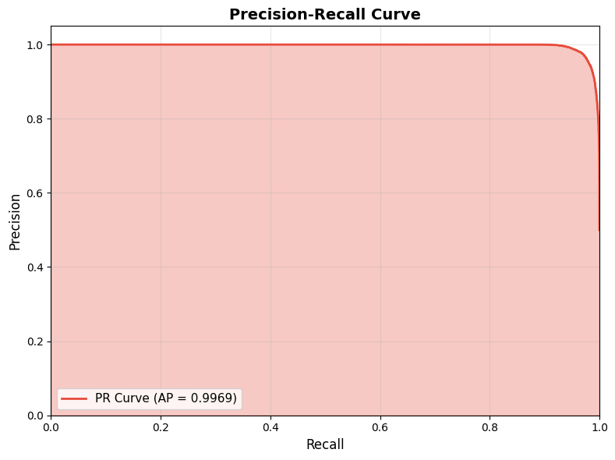

✓ Precision-Recall curve saved!

================================================================================
SECTION 12: MODEL SAVING AND LOADING
================================================================================

--- Saving Model ---
✓ Model saved to: /content/phishing_detector_model.keras
Model size: 1.85 MB
✓ Weights saved to: /content/phishing_detector_model.weights.h5

--- Loading and Verifying Model ---
✓ Model loaded from: /content/phishing_detector_model.keras
Verifying model predictions...
✓ Verification accuracy on 1000 samples: 0.9780

✓ Model loading and verification successful!

================================================================================
SECTION 13: MODEL EXPLAINABILITY (SHAP)
================================================================================

--- SHAP Explainability Analysis ---
Using 100 samples for SHAP analysis (memory efficient)
Creating SHAP explainer (this may take a few minutes)...
Calculating SHAP values...

⚠ SHAP analysis encountered an error: 'NoneType' object has no attribute 'numpy'
This is common with complex models. Falling back to alternative analysis...

--- URL Pattern Analysis ---

Correctly classified benign URLs: 48,438
Correctly classified phishing URLs: 48,650
False positives (benign → phishing): 1,562
False negatives (phishing → benign): 1,350

False Positive Examples (Benign misclassified as Phishing):
1. theroadtodomestication.com/day-four-of-the-christmas-home-tour/?replytocom=4243...
2. wikirev.org/forum/viewtopic.php?f=35&p=3028&sid=052c0f572f08e9f663b6687c44945811...
3. thrifles.blogspot.com/2015/08/schlosser-burgen-kirchen.html...
4. district.evscschools.com/cms/one.aspx?portalid=74772&pageid=5508269...
5. www.claydondrills.com/ministries/details/departement-gers...

False Negative Examples (Phishing misclassified as Benign):
1. k2sporn.com/hd-porn/...
2. life-love-sacred-art.blogspot.com/2016/09/coffee-and-crayons-free-marian-quote.h...
3. elmet33.ru/kabelnaya-produktsiya-i-metallosetki/13-kabeli-i-provoda-silovye-dlya...
4. theprogressiveexpress.com/2017/12/10/otis-redding-soul-music-legend-with-the-tim...
5. tcaanime.sisi-pisi-popi.ru/molodye-pyshnogrudye-porno-w.html...

--- URL Characteristics Analysis ---

Benign URLs:
Avg length: 61.5
Avg dots: 2.3
Avg slashes: 2.6
Avg digits: 6.2

Phishing URLs:
Avg length: 65.3
Avg dots: 2.3
Avg slashes: 2.6
Avg digits: 7.0

================================================================================
SECTION 14: PREDICTION FUNCTION FOR NEW URLs
================================================================================

--- Testing Prediction Function ---

Predictions for sample URLs:

============================================================
URL: google.com
============================================================
⚠️ PREDICTION: PHISHING
🔴 Phishing Probability: 100.00%
Confidence: 100.00%
============================================================

============================================================
URL: facebook.com/login
============================================================
⚠️ PREDICTION: PHISHING
🔴 Phishing Probability: 99.99%
Confidence: 99.99%
============================================================

============================================================
URL: secure-banking-login.suspicious-site.com/verify
============================================================
✅ PREDICTION: BENIGN
🟢 Benign Probability: 83.59%
Confidence: 83.59%
============================================================

============================================================
URL: paypal.com.fake-domain.net/signin
============================================================
✅ PREDICTION: BENIGN
🟢 Benign Probability: 59.37%
Confidence: 59.37%
============================================================

============================================================
URL: amazon.com
============================================================
⚠️ PREDICTION: PHISHING
🔴 Phishing Probability: 100.00%
Confidence: 100.00%
============================================================

============================================================
URL: free-iphone-winner.xyz/claim-prize
============================================================
✅ PREDICTION: BENIGN
🟢 Benign Probability: 97.11%
Confidence: 97.11%
============================================================

============================================================
URL: github.com/user/repo
============================================================
✅ PREDICTION: BENIGN
🟢 Benign Probability: 99.10%
Confidence: 99.10%
============================================================

============================================================
URL: login-verify-account.com/secure/bank
============================================================
⚠️ PREDICTION: PHISHING
🔴 Phishing Probability: 97.13%
Confidence: 97.13%
============================================================

================================================================================
SECTION 15: FINAL SUMMARY AND RESULTS EXPORT
================================================================================

================================================================================
FINAL TRAINING REPORT
================================================================================

╔══════════════════════════════════════════════════════════════════════════════╗
║ PHISHING URL DETECTION MODEL ║
║ 1D-CNN Architecture ║
╠══════════════════════════════════════════════════════════════════════════════╣
║ DATASET INFORMATION ║
╠══════════════════════════════════════════════════════════════════════════════╣
║ Training Samples: 500,000 ║
║ Validation Split: 10% ║
║ Test Samples: 100,000 ║
║ Max URL Length: 200 ║
╠══════════════════════════════════════════════════════════════════════════════╣
║ MODEL ARCHITECTURE ║
╠══════════════════════════════════════════════════════════════════════════════╣
║ Embedding Dimension: 64 ║
║ Conv Filters: [128, 128, 64] ║
║ Kernel Sizes: [3, 5, 7] ║
║ Dense Units: [128, 64] ║
║ Dropout Rate: 0.5 ║
╠══════════════════════════════════════════════════════════════════════════════╣
║ TRAINING CONFIGURATION ║
╠══════════════════════════════════════════════════════════════════════════════╣
║ Batch Size: 256 ║
║ Max Epochs: 20 ║
║ Learning Rate: 0.001 ║
║ Training Time: 6.85 min ║
╠══════════════════════════════════════════════════════════════════════════════╣
║ EVALUATION METRICS (TEST SET) ║
╠══════════════════════════════════════════════════════════════════════════════╣
║ Accuracy: 0.9709 ║
║ Precision: 0.9689 ║
║ Recall: 0.9730 ║
║ F1-Score: 0.9709 ║
║ ROC-AUC: 0.9965 ║
╚══════════════════════════════════════════════════════════════════════════════╝

✓ Results summary saved to: /content/results/results_summary.json

--- Saved Files ---
✓ Trained Model: /content/phishing_detector_model.keras (1890.2 KB)
✓ Training History: /content/training_history.npy (1.6 KB)
✓ Results Summary: /content/results/results_summary.json (0.6 KB)
✓ Training History Plot: /content/results/training_history.png (237.9 KB)
✓ Confusion Matrix: /content/results/confusion_matrix.png (51.1 KB)
✓ ROC Curve: /content/results/roc_curve.png (70.0 KB)
✓ PR Curve: /content/results/precision_recall_curve.png (36.9 KB)
✓ Class Distribution: /content/results/class_distribution.png (58.2 KB)
✓ URL Length Distribution: /content/results/url_length_distribution.png (73.1 KB)
✗ SHAP Analysis: Not found

================================================================================
SECTION 16: DOWNLOAD FILES
================================================================================

--- Creating Download Package ---
✓ Download package created: /content/phishing_detection_results.zip (2.39 MB)

📥 Click below to download the results:

================================================================================
TRAINING COMPLETE!
================================================================================

🎉 Congratulations! Your phishing URL detection model has been trained successfully.

📊 Model Performance:
• Accuracy: 97.09%
• Precision: 96.89%
• Recall: 97.30%
• F1-Score: 97.09%
• ROC-AUC: 0.9965

📁 Files Saved:
• Model: /content/phishing_detector_model.keras
• Results: /content/results/
• Download: /content/phishing_detection_results.zip

🔮 To use the model for predictions:
detector = PhishingURLDetector(model, config)
result = detector.predict("suspicious-url.com")

📝 For your FYP report, all visualizations are saved in the results folder.

Good luck with your Final Year Project! 🚀

================================================================================

